

Documentation of Expense Management System
Name: Rabeel Fatima

Registeration Number: sp23-BSE-032 Subject : Advance Web
Submitted to: Ma’am Yasmeen
University: COMSATS University Islamabad,Vehari Campu

Expense Manager - Complete Project Documentation

1. Project Introduction
This Expense Manager is a full-stack web application developed using React for frontend, Node.js & Express for backend, and MongoDB as database. It allows users to manage their income and expenses, track financial data, and visualize analytics using charts.
Additionally, the project includes input validation and authentication mechanisms, ensuring that user data such as email and password is properly verified before account creation and login.
It also features a dedicated Analytics Page where users can visually analyze their financial data using multiple chart types.

2. Project Features
- User Signup & Login Authentication
- Secure Password Handling
- Email & Password Validation (Authentication Validation)
- Add / Edit / Delete Transactions
- Filter Transactions (Daily, Monthly, Yearly)
- Search by Title
- Category Filtering
- Date Range Filtering
- Dashboard Summary (Income, Expense, Balance)
- Budget Limit Alert System
- Dark Mode Toggle
- Analytics Page (Bar, Pie, Line Charts)
- Daily, Monthly, Yearly Financial Analysis Visualization
- Highest Spending Category Detection
- Savings & Savings Rate Calculation

3. Project Flow
- User opens Landing Page
- User goes to Signup/Login
- After login → Dashboard opens
- User adds transactions
- Data stored in MongoDB via backend API
- Dashboard shows summary + history
- User can filter/search data
- Analytics page shows charts & insights (Bar, Pie, Line)
During signup/login, validation checks are applied on email format and password strength before allowing access.
Analytics page displays daily, monthly, and yearly data in graphical form for better understanding.

4. Folder Structure

Backend:
- models (User, Transaction)
- controllers (authController, transactionController)
- routes (authRoutes, transactionRoutes)
- middleware (authMiddleware)
- server.js

Frontend:
- src/pages (Login, Signup, Dashboard, Analysis, Landing)
- src/components
- api.js (API calls)
- App.jsx (routing)

5. Backend Explanation
- Models: Define database schema (User, Transaction)
- Controllers: Handle logic like signup, login, CRUD operations
- Routes: Define API endpoints
- Middleware: Used for authentication (JWT) and request validation
- Server.js: Main backend entry point
Validation is implemented in backend to check:
- Valid email format
- Strong password requirements (length, characters, etc.)
- Duplicate email prevention
Backend also provides filtered data (daily, monthly, yearly) for analytics visualization.

6. Frontend Explanation
- Landing Page: Navigation (Login/Signup)
- Login Page: User authentication with validation
- Signup Page: Create account with email & password validation
- Dashboard: Manage transactions, filters, dark mode
- Analysis Page: Displays Bar Chart, Pie Chart, and Line Chart
Analytics Page Features:
- Bar Chart → Shows income vs expense comparison
- Pie Chart → Shows category-wise expense distribution
- Line Chart → Shows trends over time
- Supports Daily, Monthly, and Yearly data visualization
Frontend also performs client-side validation before sending data to backend.

7. REST APIs Used

Auth APIs:
- POST /api/auth/signup
- POST /api/auth/login

Transaction APIs:
- GET /api/transactions
- POST /api/transactions
- PUT /api/transactions/:id
- DELETE /api/transactions/:id

8. Installation Commands (VS Code)

Backend:
npm init -y
npm install express mongoose cors dotenv

Frontend:
npm create vite@latest
npm install
npm install recharts react-router-dom

9. Conclusion
This project demonstrates full-stack development with authentication, validation, CRUD operations, filtering, and data visualization. It helps users manage finances efficiently while ensuring secure and validated user input through email and password authentication mechanisms.
Additionally, the Analytics Page enhances user experience by presenting financial data through Bar, Pie, and Line charts, allowing users to analyze their daily, monthly, and yearly financial patterns effectively.

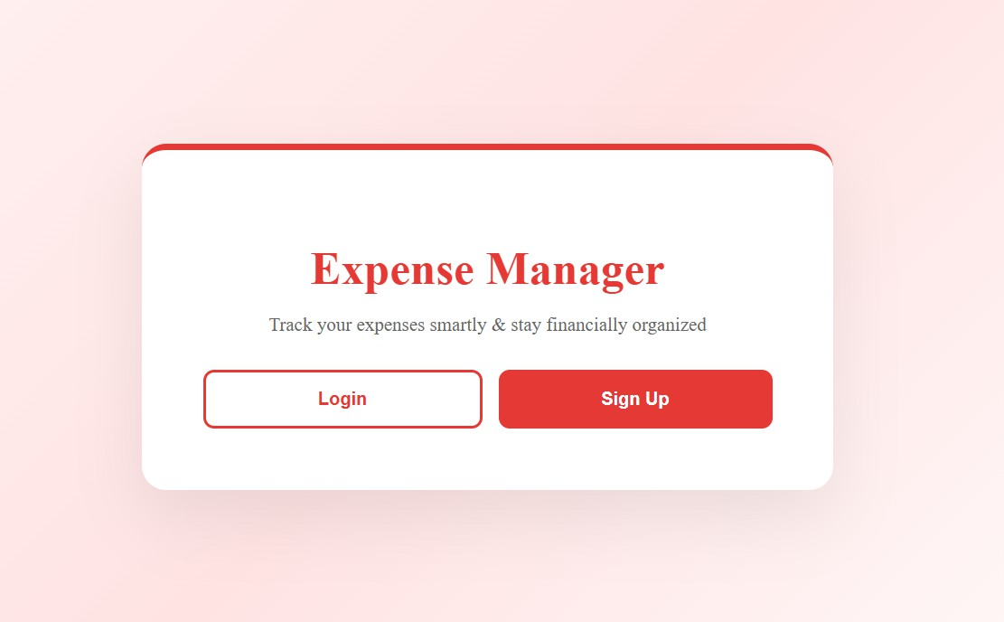
Screenshots:

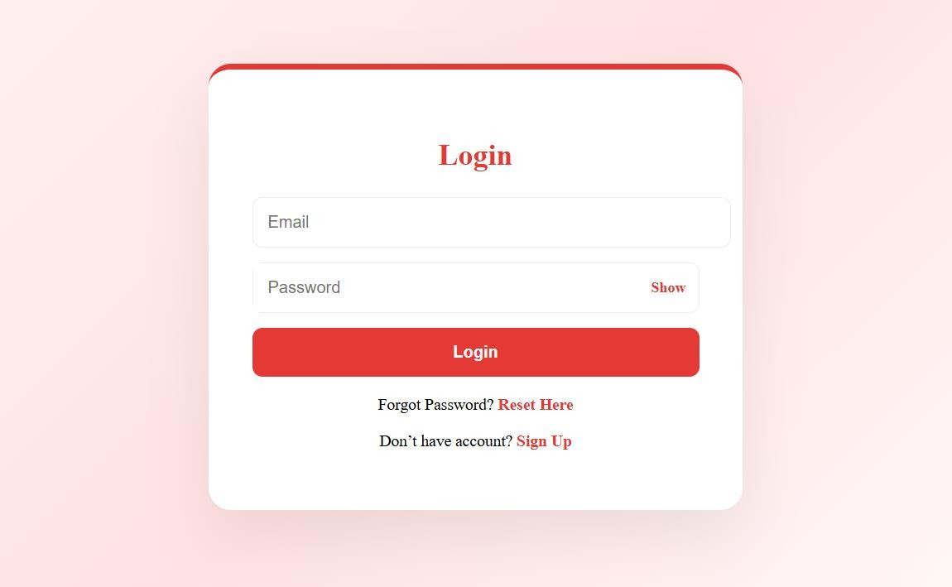
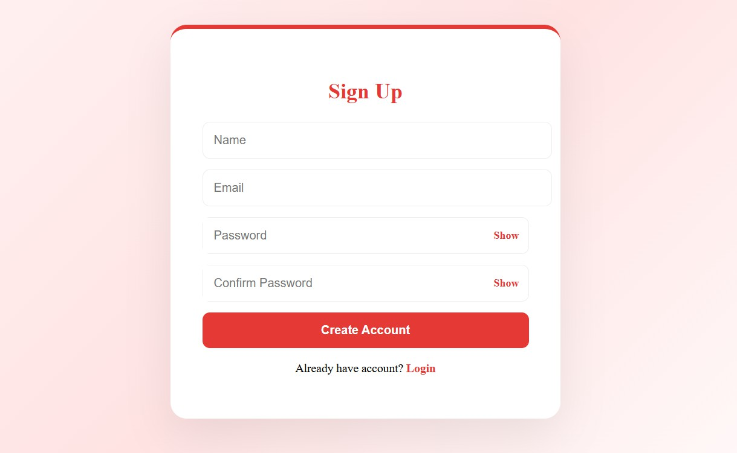

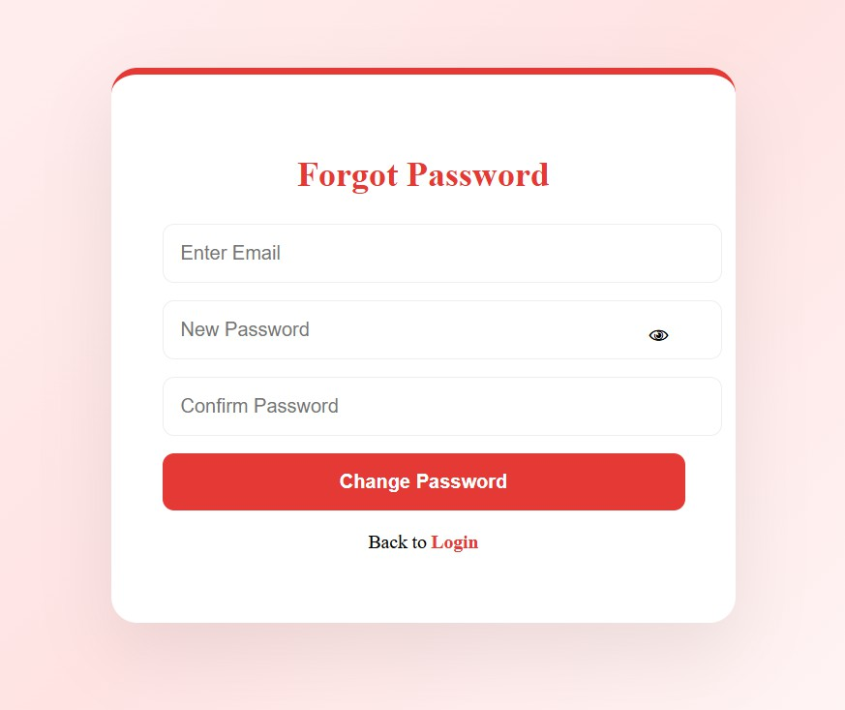
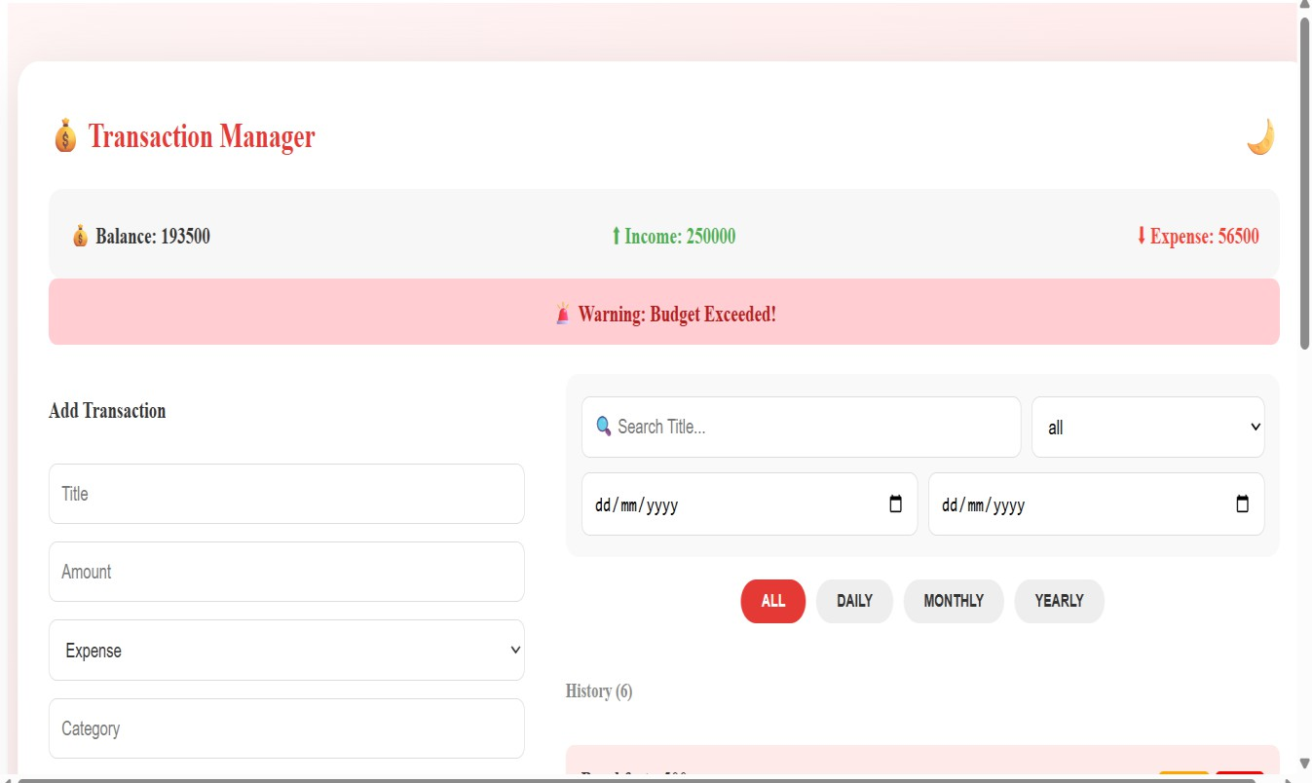

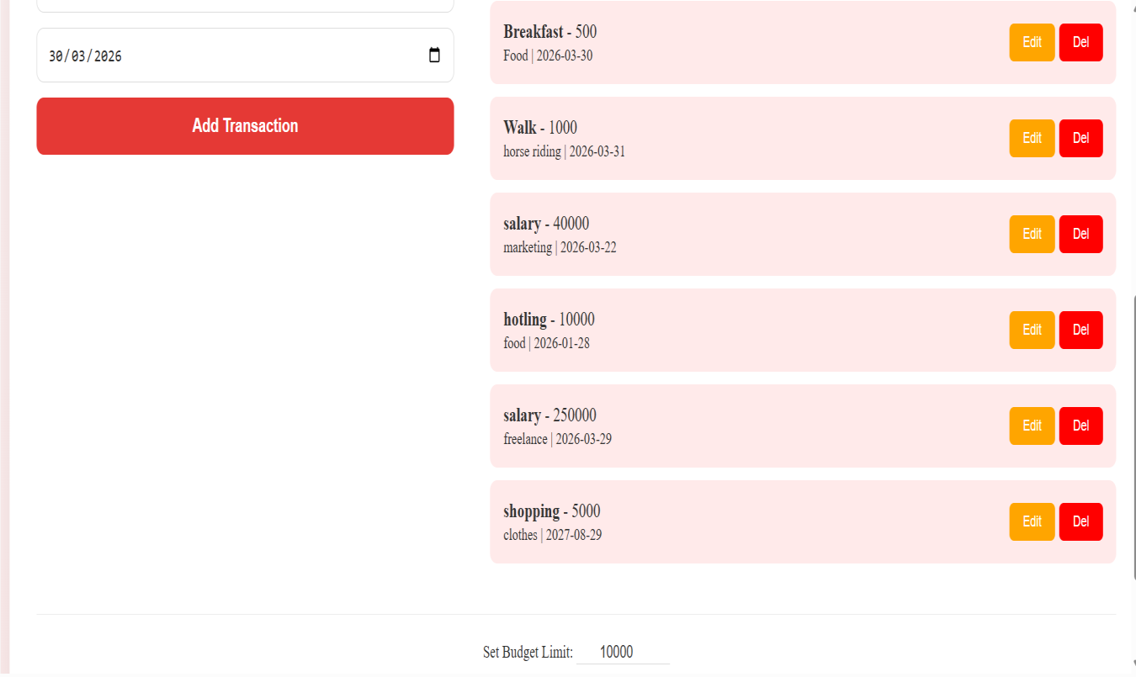
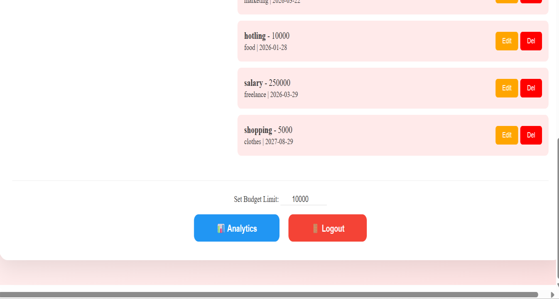

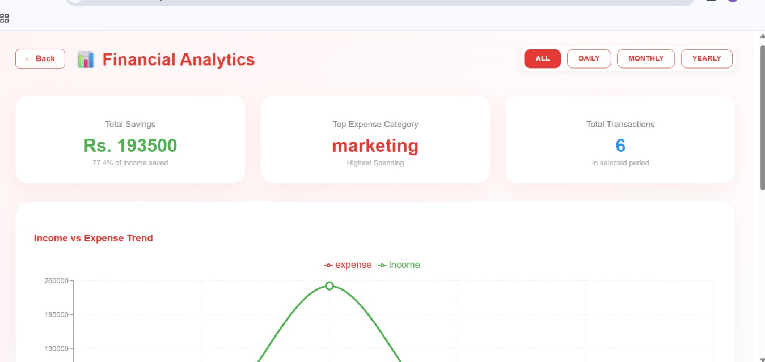
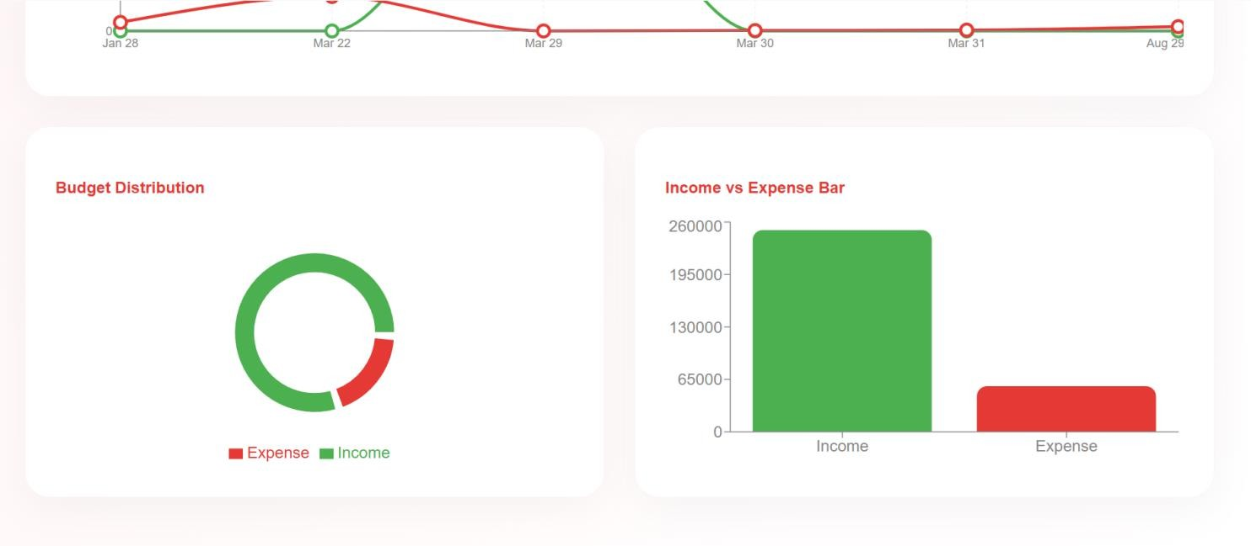

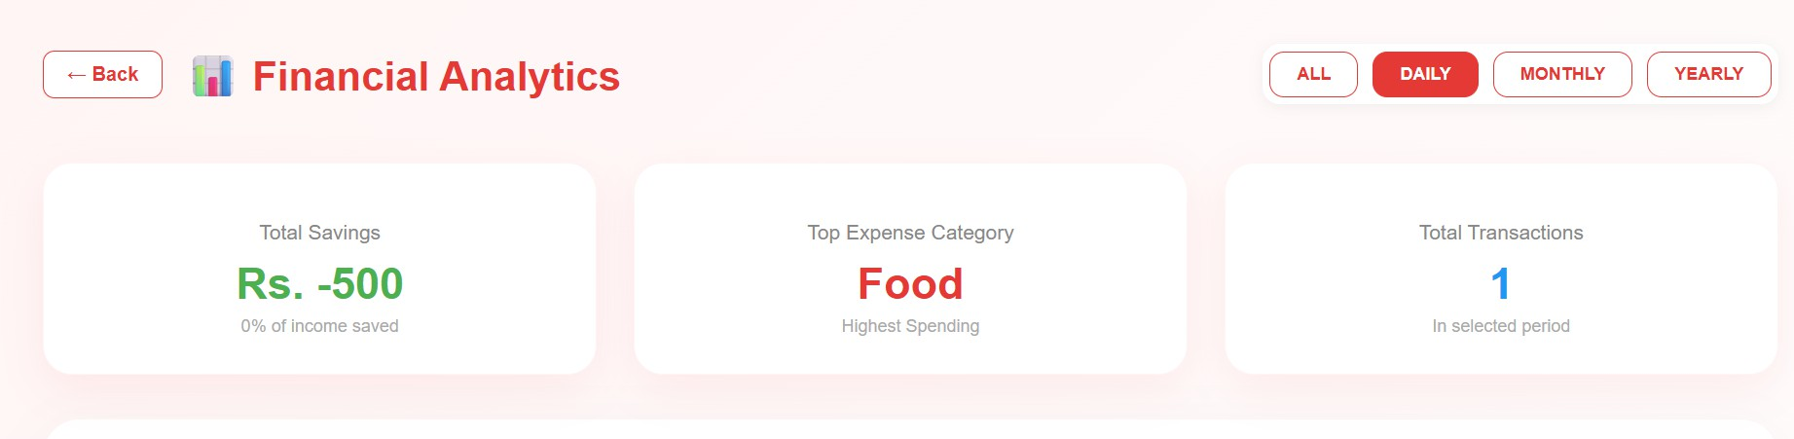

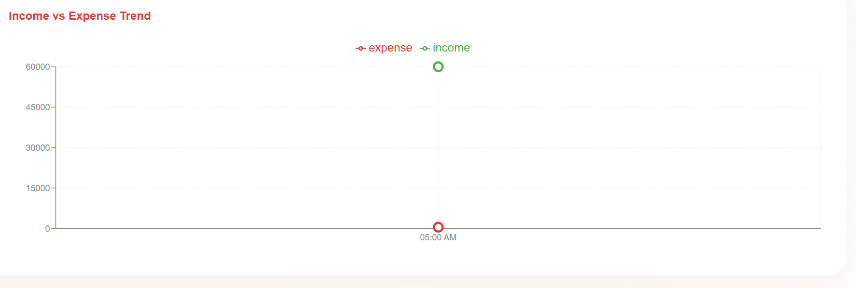
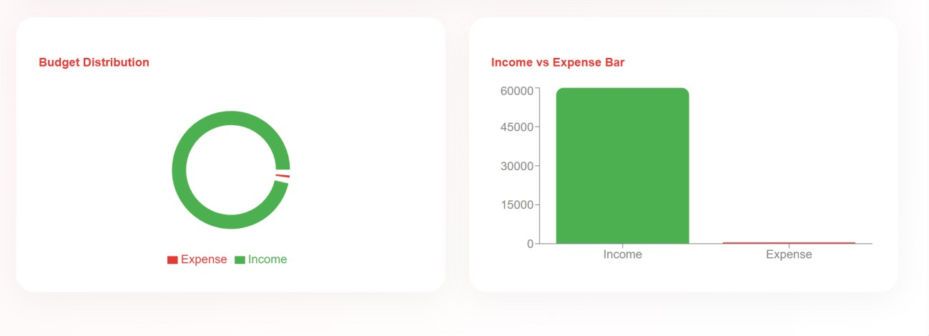
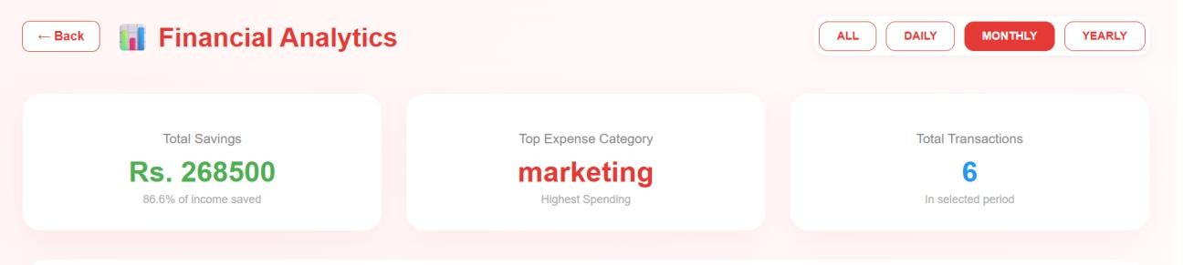

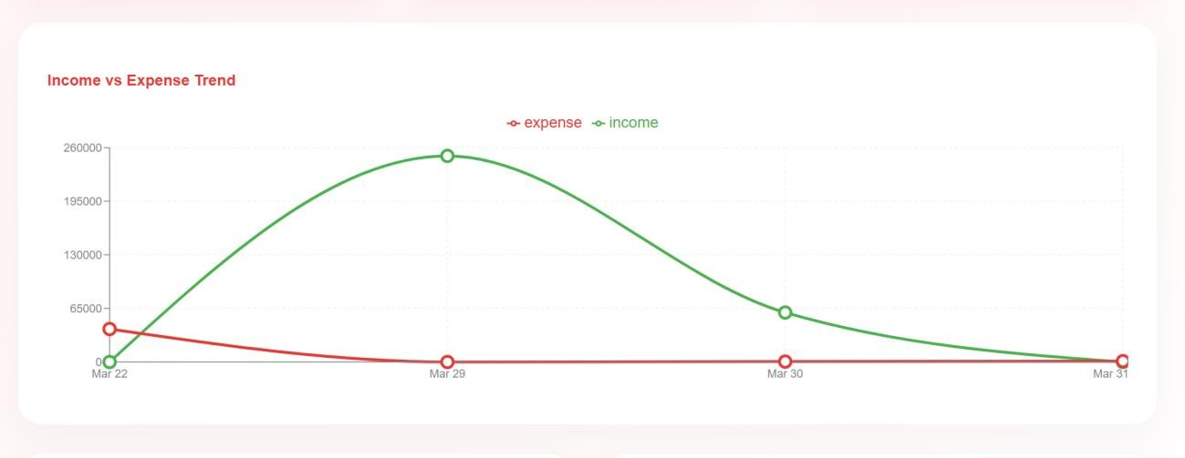
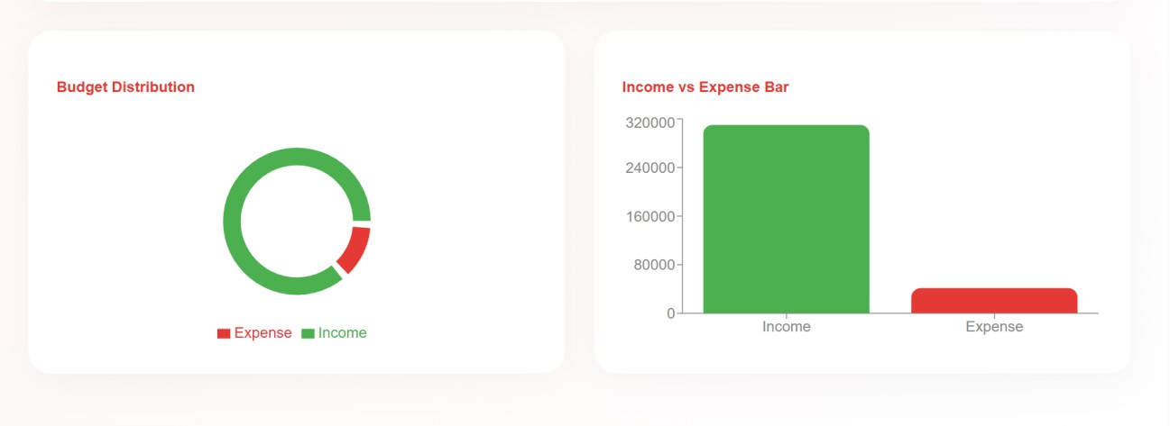
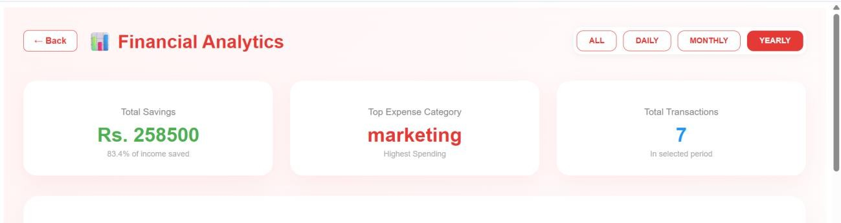

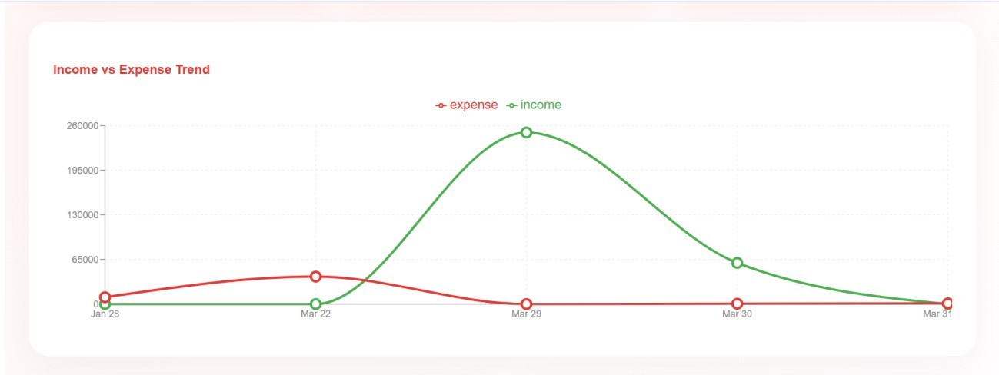
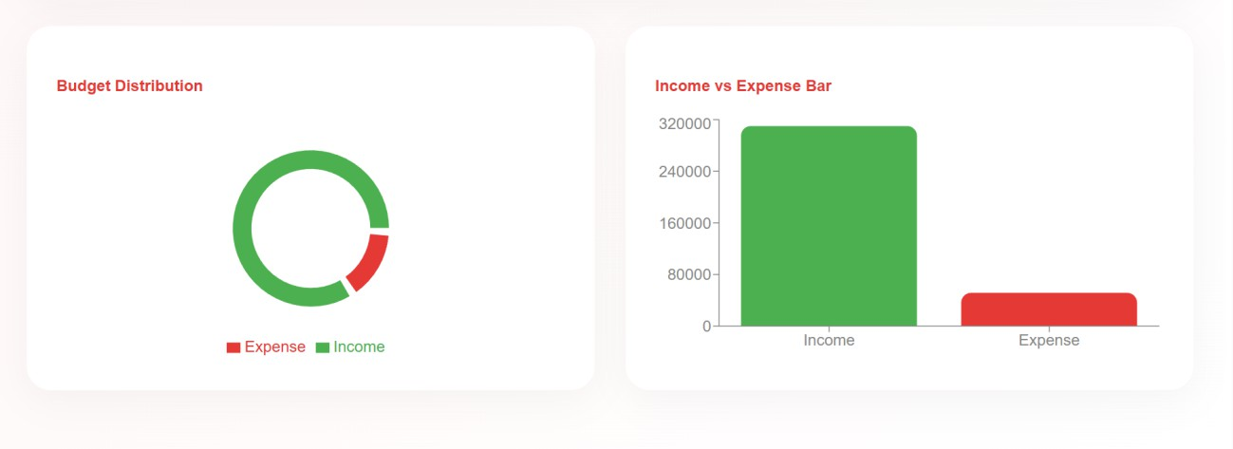

Database:

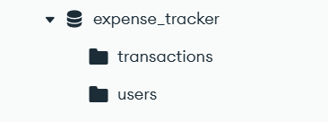
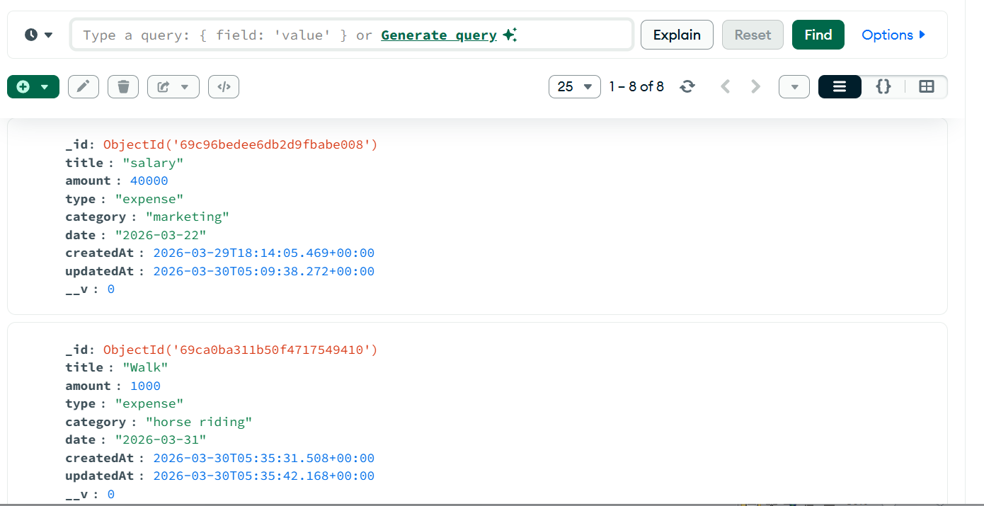
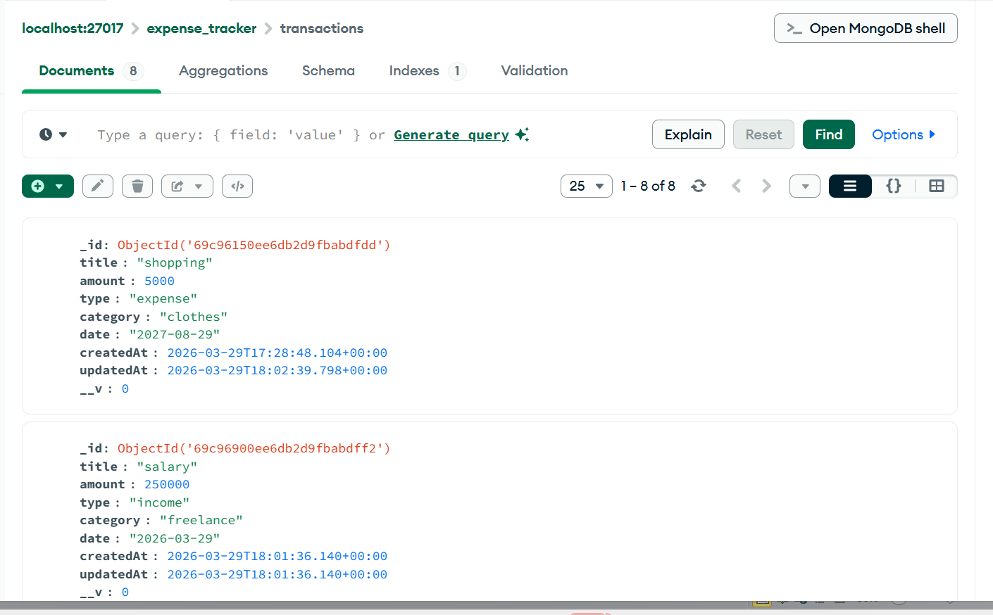

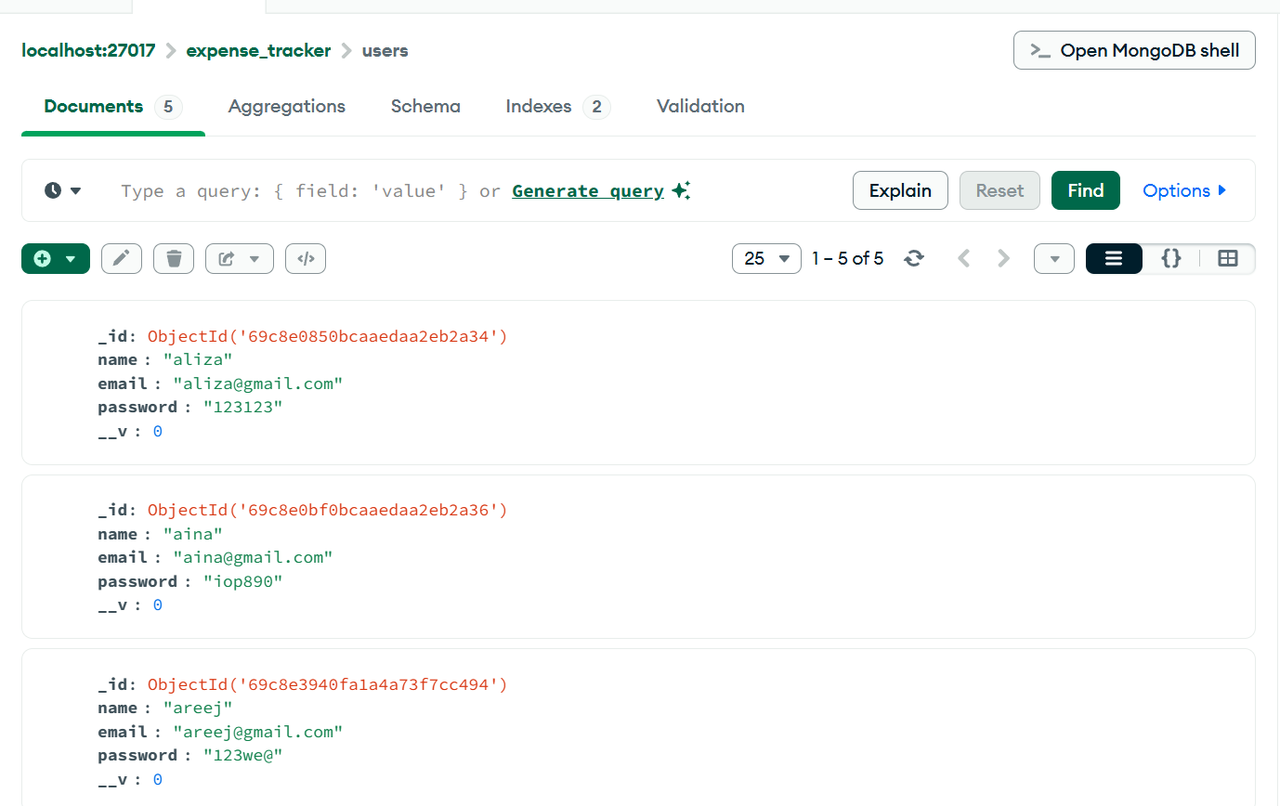
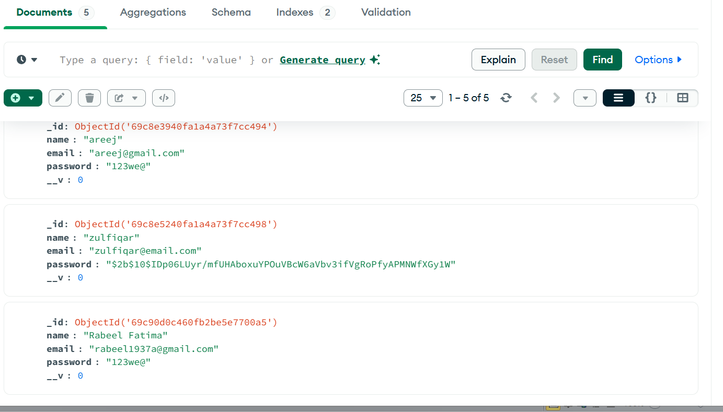

Recording:


Recording Expense management System.mp4
Github link:
https://github.com/rabeelfatma/advance_web_Rabeel_032

